
Generative Models vs Traditional AI-Driven Anomaly Detection in Large-Scale System Logs – A Comparative Study
Thesis Report

July 18, 2026
Fall 2024 Air University
Muhammad Asad Mahmood Khan Roll # 243260 MSAI-4


Abstract
The escalating scale and complexity of distributed computing architectures—specifically Hadoop (HDFS), Apache Spark, and OpenStack—have rendered manual and rule-based log monitoring fundamentally intractable. This research presents a comprehensive comparative study evaluating Traditional Machine Learning (ML), sequence-based Deep Learning (DL), and Generative AI models for the automated detection of system anomalies within massive, unstructured log collections.
Initial benchmarking demonstrates a critical functional dichotomy in current industry standards: traditional supervised algorithms achieve high precision on structured data but are brittle, relying heavily on labor-intensive manual feature engineering (e.g., Event Count Matrices) and labeled datasets. Furthermore, traditional unsupervised baselines, such as Isolation Forest, exhibit significantly lower efficacy when processing high-dimensional sequences, exposing a severe gap in identifying unknown, zero-day errors.
To transcend these limitations, this thesis rigorously evaluates deep sequence and Generative AI architectures (including LSTMs, VAEs, and GANs). To ensure an accurate and isolated assessment across heterogeneous environments, models are independently trained and tested within the same respective dataset boundaries for HDFS, Spark, and Hadoop, establishing true operational baselines without cross-system data contamination.
This study ultimately aims to delineate the operational boundaries of these paradigms. The findings reveal that while supervised Deep Learning successfully eliminates the need for manual feature extraction, Generative AI provides a fundamentally superior balance of automation by operating under a strictly normal-only training paradigm. By thoroughly mapping these architectures across multiple platforms, this research validates the capacity of Generative models to discover unknown anomalies without prior exposure, while also detailing the critical trade-offs regarding precision and noise resilience in highly concurrent environments like Apache Spark.
Index Terms—Generative Models, Traditional AI-Driven Anomaly Detection, Large-Scale System Logs.

TABLE OF CONTENTS
I. Introduction
A. Problem Statement
B. Objectives and Research Questions
II. Literature Review
A. Traditional Machine Learning
B. Deep Learning Sequence Models
C. Generative & Transformer Models
D. Research Gap
III. Methodology
A. Phase 1: Multi-Source Dataset Collection
B. Phase 2: Log Preprocessing & Parsing
C. Phase 3: Comparative Model Training
D. Phase 4: Cross-Platform Testing
E. Phase 5: Comparative Analysis & Final Evaluation
IV. Results & Analysis
- A. Baseline Performance (HDFS v1)
    - Traditional Machine Learning Results
    - Deep Learning (Supervised) Results
    - Generative AI Results
    - Comparative Analysis Synthesis (HDFS)
- B. Spark Logs Analysi
    - Machine Learning Results
    - Deep Learning Results
    - Generative AI Results
    - Spark Comparative Analysis Synthesis
- C. Hadoop Logs Analysis
    - Traditional Machine Learning Log
    - Deep Learning (LSTM and CNN
    - Generative AI (VAE and GAN)
    - Hadoop Comparative Analysis Synthesis
- D. Overall Performance Synthesis (Spark vs. Hadoop)
V. Conclusion & Future Work
- A. Conclusion
- B. Future Work
VI. References

I. INTRODUCTION
System logs serve as the definitive operational artifacts and the primary source of truth for diagnosing failures, tracking execution flows, and ensuring security within modern cloud infrastructures. In contemporary distributed computing paradigms—such as the Hadoop Distributed File System (HDFS) and Apache Spark frameworks—a single user transaction routinely cascades into complex execution traces spanning thousands of interconnected and concurrent nodes. This immense concurrency generates terabytes of heterogeneous, unstructured, and semi-structured log data at unprecedented velocities.
Historically, system administrators relied on manual inspection, simple keyword matching (e.g., flagging "FATAL" or "ERROR" strings), and static, rule-based heuristics to identify performance bottlenecks or impending system crashes. However, as infrastructural scale and software complexity continue to grow exponentially, these traditional paradigms have become fundamentally obsolete. The sheer volume, high dimensionality, and continuous semantic evolution of these log formats make it practically impossible for human operators or rigid diagnostic scripts to capture the nuanced, temporal deviations that often precede catastrophic system failures.
Consequently, the industry has necessitated a critical paradigm shift toward Artificial Intelligence and automated telemetry. The application of sophisticated Artificial Intelligence—spanning Traditional Machine Learning (ML), Deep Learning (DL), and Generative AI architectures—to parse, embed, and analyze these massive log collections has emerged as a pivotal research frontier. Developing robust, automated anomaly detection systems is no longer just an optimization strategy, but an operational necessity for maintaining system reliability, ensuring high availability, and mitigating the immense costs associated with infrastructure downtime.
A. Problem Statement
As distributed computing environments, such as Hadoop and Apache Spark, continue to scale in complexity, system logs remain the primary diagnostic artifact for troubleshooting and performance monitoring. However, the sheer volume, velocity, and unstructured nature of these logs have rendered manual, rule-based inspection obsolete. Consequently, current industry standards for automated log anomaly detection are paralyzed by a critical functional dichotomy between accuracy and adaptability.
- Brittleness of Supervised ML:
Traditional discriminative models, including Support Vector Machines (SVM) and extreme gradient boosting (XGBoost), can achieve exceptionally high detection accuracy in closed-world scenarios. However, they are fundamentally brittle. These architectures are entirely dependent on rigid, manual feature engineering (e.g., Event Count Matrices) and extensive, pre-labeled anomaly datasets. This reliance causes them to fail catastrophically in the face of concept drift—such as when log syntax naturally evolves during software updates, or when models are ported across heterogeneous system architectures.
- Inefficacy of Unsupervised Baselines:
Conversely, traditional unsupervised techniques (e.g., Isolation Forest, One-Class SVM) attempt to bypass the need for labeled data by isolating statistical outliers. Yet, they consistently struggle to map the complex, temporal, and sequential dependencies inherent in distributed execution traces. This structural blindness results in unacceptably high false-positive rates and poor detection efficacy when encountering novel, unknown error patterns (zero-day anomalies) within noisy, highly concurrent environments. There is a critical lack of a unified framework that combines the high accuracy of supervised learning with the flexibility of unsupervised discovery.
Ultimately, there remains a critical lack of a robust, unified framework capable of bridging this operational gap. Existing paradigms force a compromise: engineering teams must choose between the high precision of supervised learning—which demands unsustainable manual labeling and feature extraction—and the flexibility of unsupervised discovery, which currently lacks the contextual depth to operate reliably across diverse, real-world systems without triggering alert fatigue.
B. Objectives and Research Questions
This research aims to benchmark traditional supervised and unsupervised models on the HDFS, Hadoop and Spark datasets to establish a baseline for known error detection. It evaluates discriminative Deep Learning (DL) sequence models for anomaly detection without manual feature extraction, and validates Generative AI architectures to determine their superiority in detecting unknown anomalies and their performance consistency across distinct platform datasets. Ultimately, it conducts a tri-fold comparative study producing a definitive performance matrix comparing ML, DL, and Generative AI.
The core research questions are:
- RQ1: To what extent can Generative AI architectures maintain consistent anomaly detection performance across distinct, heterogeneous distributed systems (e.g., evaluated independently on HDFS and Spark) compared to Traditional Supervised models?
- RQ2: Can Generative Deep Learning models eliminate the dependency on manual feature engineering required by traditional AI, while maintaining high F1-scores?
RQ3: Can deep generative models significantly outperform traditional unsupervised baselines in detecting unknown 'zero-day' anomaly patterns?
II. LITERATURE REVIEW
A. Traditional Machine Learning
Foundational studies in log anomaly detection heavily relied on Traditional Machine Learning algorithms to classify system states. Early research demonstrated that supervised methods, such as Decision Trees, Support Vector Machines (SVM), and ensemble techniques like Random Forest and XGBoost, can achieve exceptionally high accuracy and F1-scores on structured, well-balanced log datasets. However, the efficacy of these models is entirely predicated on rigid, manual preprocessing pipelines. These approaches require raw unstructured logs to be parsed into fixed templates using tools like Drain or Spell, followed by the manual construction of numerical feature vectors, most commonly Event Count Matrices or TF-IDF (Term Frequency-Inverse Document Frequency) weightings.
While highly accurate for specific, static datasets under closed-world assumptions, these discriminative models exhibit significant brittleness. They lack portability; a slight alteration in log syntax due to a software update or a shift in system architecture can catastrophically degrade their predictive performance. Furthermore, traditional unsupervised baselines, such as Isolation Forest and One-Class SVM, were introduced to mitigate the dependency on labeled data. While useful for isolating statistically rare events, literature indicates they frequently struggle with high-dimensional sequential data, often resulting in unacceptably high false-positive rates when applied to complex, concurrent system logs.
B. Deep Learning Sequence Models
To address the bottleneck of manual feature engineering and the limitations of static count matrices, subsequent literature shifted towards Deep Learning (DL) sequence models. Inspired by Natural Language Processing (NLP), architectures such as DeepLog and LogRobust modeled system logs as temporal sequences of natural language. By employing Recurrent Neural Networks (RNNs) and their more advanced variants—Long Short-Term Memory (LSTM) networks and Gated Recurrent Units (GRUs)—researchers successfully mapped the temporal dependencies and execution logic inherent in distributed systems.
These supervised deep learning models achieved high F1-scores by autonomously learning sequential patterns and execution paths directly from the parsed log event IDs, effectively reducing the need for manual feature extraction. Furthermore, spatial models like Convolutional Neural Networks (CNNs) have been successfully adapted to detect local anomalies within log windows. Despite these advancements, supervised DL sequence models still present notable limitations. They often require extensive, task-specific tuning and are highly vulnerable to the "Out-of-Vocabulary" (OOV) problem, where previously unseen log events—common in dynamic cloud environments—cause the models to misclassify normal operations as anomalous.
C. Generative & Transformer Models
The most recent advancements in the domain leverage self-supervised Generative AI and Transformer-based architectures to understand the deep semantic context of system logs. Moving beyond simple sequence memorization, models like LogBERT utilize bidirectional attention mechanisms to capture complex contextual relationships between log events, achieving near-perfect F1-scores on standardized benchmarks.
In parallel, generative deep learning architectures—specifically Variational Autoencoders (VAEs), Generative Adversarial Networks (GANs), and LSTM-Autoencoders—have been proposed to tackle the challenge of zero-day anomaly detection. These models operate under a strictly unsupervised paradigm; they are trained exclusively on normal operational data to learn the underlying distribution of a healthy system. Anomalies are then detected based on high reconstruction errors or probabilistic deviations. While these generative models theoretically solve the dependency on labeled anomaly data and manual feature engineering, current literature highlights critical operational trade-offs. They are computationally expensive to train and deploy, and their sensitivity to reconstruction thresholds often leads to performance degradation (specifically precision collapse) when deployed in highly concurrent, noisy environments like Apache Spark.
D. Research Gap
Despite the rapid evolution of automated log analysis frameworks, a critical gap remains in the literature regarding the evaluation of architectural performance consistency across diverse distributed system topologies. The vast majority of existing studies evaluate newly proposed models under highly isolated, single-dataset benchmarks. While an architecture might achieve near-flawless performance when trained and tested on a structurally consistent and homogeneous dataset like HDFS block logs, this narrow evaluation fails to reflect the operational realities of complex enterprise environments.
Specifically, current literature lacks comprehensive, multi-source comparative research that subjects Traditional ML, Deep Learning, and Generative AI to identical empirical conditions across fundamentally distinct system datasets—such as the highly localized block operations of HDFS, the volatile and concurrent task execution traces of Apache Spark, and the massive, heterogeneous system events of Hadoop/OpenStack. Consequently, there is insufficient empirical proof to confirm whether Generative AI architectures can consistently outperform traditional supervised baselines across the board when operating under a strictly unsupervised, normal-only training paradigm.
Furthermore, existing cross-platform literature often misrepresents model adaptability by attempting cross-system contamination or utilizing unevenly preprocessed features. There is a glaring deficiency in systematic studies that independently train and validate these diverse model classes within the respective boundaries of multiple individual systems to evaluate their true native baselines without relying on labor-intensive, manual feature extraction. By failing to rigorously establish these separate operational baselines, existing research leaves the actual trade-off between absolute accuracy (precision) and architectural autonomy (feature engineering elimination) largely unresolved across complex, real-world distributed architectures.
III. METHODOLOGY
This section outlines the five-phase comparative study methodology used to evaluate Traditional ML, Deep Learning, and Generative AI for log anomaly detection.
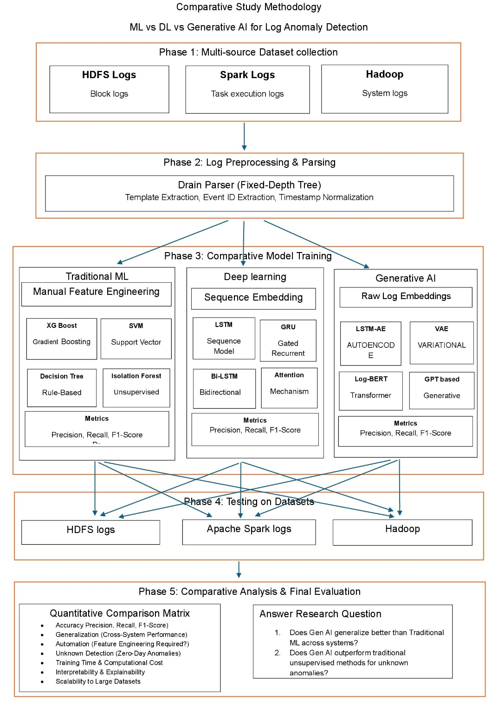
A. Mathematical Formulation of the Detection Problem
The core challenge in automated log anomaly detection is identifying sequence deviations within massive, unstructured event streams. Let the raw log sequence be defined as a continuous stream of events $S=\left\{e_{1},e_{2},…,e_{T}\right\}$, where each $e_{t}$ represents a parsed log event template at timestamp $t$.
The objective of the anomaly detection system is to learn a mapping function $f:S→\left\{0,1\right\}$, where $0$ denotes normal execution and $1$ denotes a system anomaly.

Phase 1: Multi-Source Dataset Collection
A multi-source repository is utilized to ensure rigorous comparative testing across heterogeneous environments:
- HDFS Logs: Collection of block logs.
- Apache Spark Logs: Collection of task execution logs.
- Hadoop & OpenStack: Collection of system logs.
B. Phase 2: Log Preprocessing & Parsing (Enhanced)
Raw unstructured logs cannot be directly ingested by spatial or sequential models. Raw logs are processed using the Drain Parser, a Fixed-Depth Tree approach. The preprocessing pipeline involves:
- Template Extraction: Utilizing heuristics to separate static text from dynamic variables (e.g., IPs, block IDs).
- Event ID Extraction: Assigning a unique identifier to each structural template.
- Timestamp Normalization: Standardizing chronological deltas to capture execution latency.
C. Phase 3: Comparative Model Architectures (Enhanced)
The study implements three parallel analytical pipelines:
1. Traditional Machine Learning (Manual Feature Engineering) These models depend heavily on the aggregation of Event Count Matrices.
- XGBoost & Random Forest: Utilize gradient boosting and decision tree ensembles to build non-linear decision boundaries across structured event distributions.
- Isolation Forest: Operates under the assumption that anomalies are "few and different," isolating instances by randomly selecting features and splitting values. The anomaly score $s\left(x,n\right)$ for an instance $x$ is defined as:
$$s\left(x,n\right)=2^{-\frac{E\left(h\left(x\right)\right)}{c\left(n\right)}}$$
where $h\left(x\right)$ is the path length and $c\left(n\right)$ is the average path length of unsuccessful searches in a Binary Search Tree.
2. Deep Learning (Sequence Embedding)
This pipeline evaluates sequence models capable of learning from log data without the rigid manual feature engineering required by traditional ML. Models incorporate Attention Mechanisms, Bidirectional Bi-LSTM, Gated Recurrent GRU, and Sequence Model LSTM.
3. Generative AI (Raw Log Embeddings) Generative AI models leverage raw, self-supervised log embeddings. These models are trained strictly on normal operational data to learn the underlying distribution.
- Variational Autoencoder (VAE): The VAE maps input sequences into a latent probabilistic space. The network optimizes the Evidence Lower Bound (ELBO):
$$L\left(θ,ϕ;x\right)=E_{q_{ϕ}\left(z|x\right)}\left[{\log{p}}_{θ}\left(x|z\right)\right]-D_{KL}\left(q_{ϕ}\left(z|x\right)||p\left(z\right)\right)$$
Where the anomaly score is derived from the reconstruction probability.
- LSTM-AE Autoencoder: Reconstructs sequences over time. High reconstruction errors serve as the primary threshold for anomaly detection.
D. Phase 4: Training and Testing Dynamics
To thoroughly assess model efficacy, each trained model is evaluated using a strict train-test split (e.g., an 80/20 division) sourced directly from the exact same dataset.
- Intra-System Validation: The methodology strictly mandates training and testing on the same dataset (e.g., training on HDFS and testing on HDFS) to accurately baseline the system's normal operational parameters.
- Independent System Verification: This self-contained validation is independently repeated across the HDFS, Apache Spark, and Hadoop/OpenStack log collections. This ensures the models' performance consistency is verified across distinct system environments without cross-contaminating the training distributions.
E. Phase 5: Comparative Analysis & Final Evaluation
Models are assessed using a Quantitative Comparison Matrix focusing on metrics such as Precision, Recall, and F1-Score. The evaluation also measures Performance Consistency (evaluation across individual system datasets), Automation (feature engineering requirements), Unknown Detection (zero-day anomalies), Training Time, Interpretability, and Scalability to large datasets. This matrix will directly answer the core research questions regarding Generative AI's capability to maintain high performance across systems and outperform traditional unsupervised methods.
IV. RESULTS & ANALYSIS
A. Baseline Performance (HDFS v1)
This section documents the comprehensive benchmarking phase evaluating Traditional Machine Learning, Deep Learning, and Generative AI pipelines. Models were evaluated using a strict 80% training and 20% testing split on the HDFS log dataset. The dataset presents a severe class imbalance challenge, comprising 558,223 normal log vectors and 16,838 anomaly vectors. The 20% holdout test set contains a total of 115,013 instances, with 111,645 normal cases and 3,368 anomalies. To address the severe class distribution disparity during training, algorithms like the XGBoost classifier incorporated automated minority class weighting adjustments.
1) Traditional Machine Learning Results:
In this phase, XGBoost and Support Vector Machine (SVM) were applied to detect anomalies in HDFS log data using manually engineered event count features.
- XGBoost: Achieved near-perfect performance, with an anomaly precision of 0.9985, recall of 0.9997, and F1-score of 0.9991. The model made only 5 false positive errors and missed just 1 anomaly out of 3,368 in the test set.
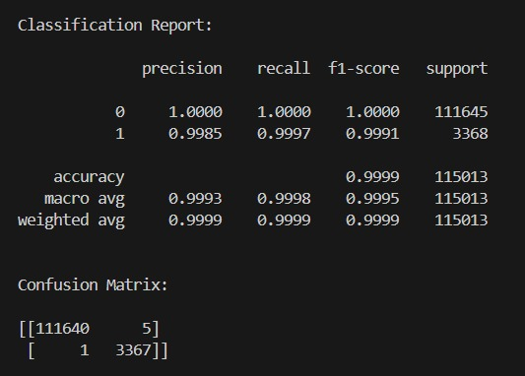
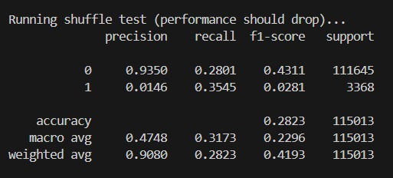
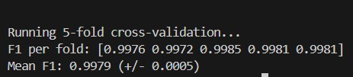

- SVM: Demonstrated strong baseline performance, achieving an anomaly precision of 0.9634, recall of 0.9994, and F1-score of 0.9811. However, it produced 128 false positives and missed 2 anomalies.
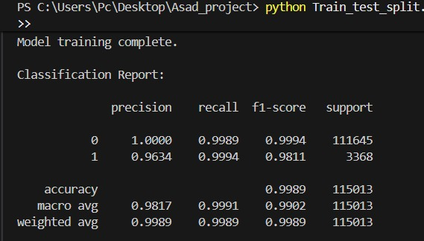
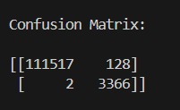
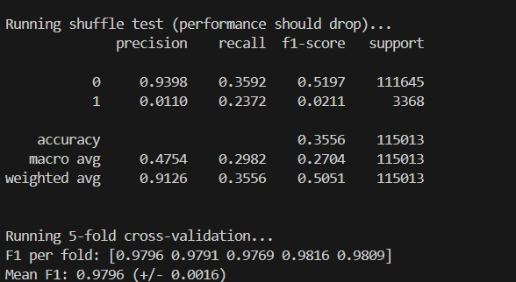

XGBoost distinctly outperformed SVM across all key parameters, highlighting its superior capacity to construct non-linear decision boundaries across complex event distributions.
2) Deep Learning (Supervised) Results:
The supervised Deep Learning pipeline evaluated sequence models capable of learning from log data without the rigid manual feature engineering required by traditional ML.
- LSTM: The Long Short-Term Memory network achieved an anomaly precision of 0.9808, a recall of 0.9988, and an F1-score of 0.9897. The model produced 66 false positives and missed 4 anomalies, while maintaining a perfect ROC-AUC of 1.0.
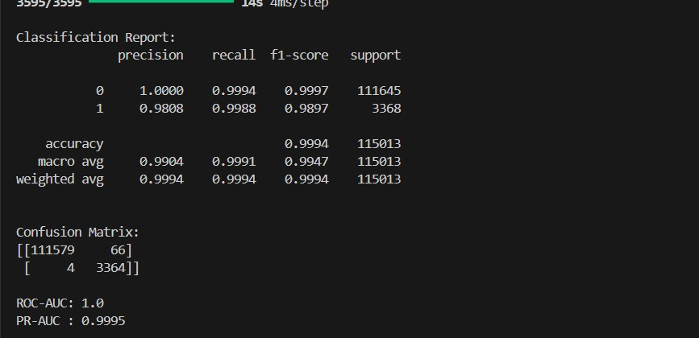
- GRU: The Gated Recurrent Unit performed comparably to the LSTM, achieving a precision of 0.9808, a recall of 0.9991, and an F1-score of 0.9899. It also produced 66 false positives but missed only 3 anomalies, similarly achieving an ROC-AUC of 1.0.
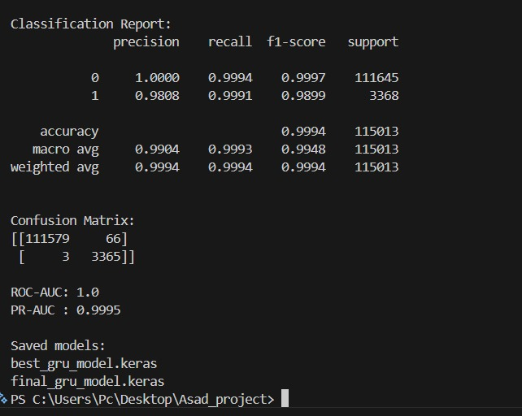
3) Generative AI Results:
The Generative AI models were trained exclusively on normal data sequences (normal-only), evaluating their capability to reconstruct logs and detect anomalies through reconstruction errors without relying on supervised anomaly labels.
- LSTM Autoencoder: Achieved an anomaly precision of 0.7232, a recall of 0.8818, and an F1-score of 0.7946. The model resulted in 1,137 false positives and 398 missed anomalies, with an ROC-AUC of 0.9964 and PR-AUC of 0.9049.
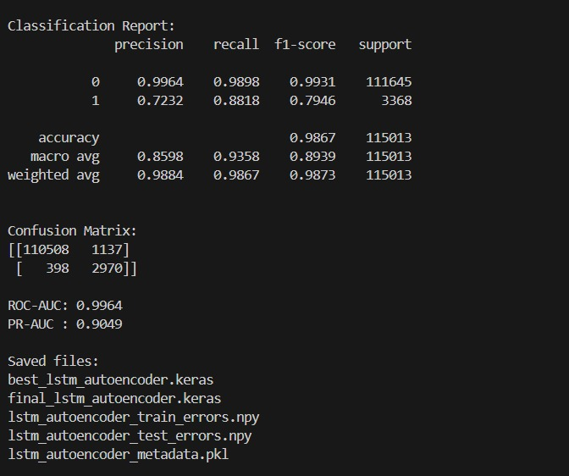
- LSTM-VAE: The Variational Autoencoder yielded an anomaly precision of 0.6944, a recall of 0.7429, and an F1-score of 0.7178. It generated 1,101 false positives and 866 missed anomalies, achieving an ROC-AUC of 0.9876 and PR-AUC of 0.7854.
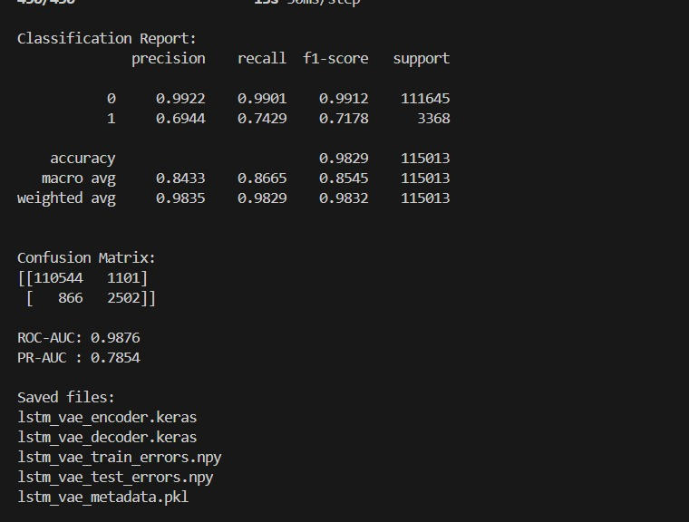
4) Comparative Analysis Synthesis (HDFS):
The benchmarking results present a clear trade-off between absolute accuracy and functional autonomy.
- Supervised Dominance: Traditional supervised models like XGBoost achieve near-perfect F1-scores (0.9991). However, their reliance on manual Event Count Matrices limits operational scalability.
- Deep Learning Autonomy: Supervised Deep Learning sequence models (LSTM and GRU) successfully matched this high accuracy (F1-scores of ~0.99) while eliminating the need for rigid manual feature extraction, proving their efficacy at understanding sequential log patterns.
- Generative Potential: The Generative AI models (LSTM Autoencoder and VAE) exhibit lower raw precision and recall metrics but operate under a fundamentally different, strictly unsupervised paradigm. Because they are trained exclusively on normal system behavior, their F1-scores (~0.71 - 0.79) represent a baseline capability for discovering unknown, zero-day anomalies.

Model | Type | Anomaly Precision | Anomaly Recall | Anomaly F1 | ROC-AUC | PR-AUC
XGBoost | Traditional ML | 99.85% | 99.97% | 99.91% | - | -
SVM | Traditional ML | 96.34% | 99.94% | 98.11% | - | -
LSTM | Supervised DL | 98.08% | 99.88% | 98.97% | 100.00% | 99.95%
GRU | Supervised DL | 98.08% | 99.91% | 98.99% | 100.00% | 99.95%
LSTM Autoencoder | Generative/ Normal-only | 72.32% | 88.18% | 79.46% | 99.64% | 90.49%
LSTM-VAE | Generative / Normal-only | 69.44% | 74.29% | 71.78% | 98.76% | 78.54%
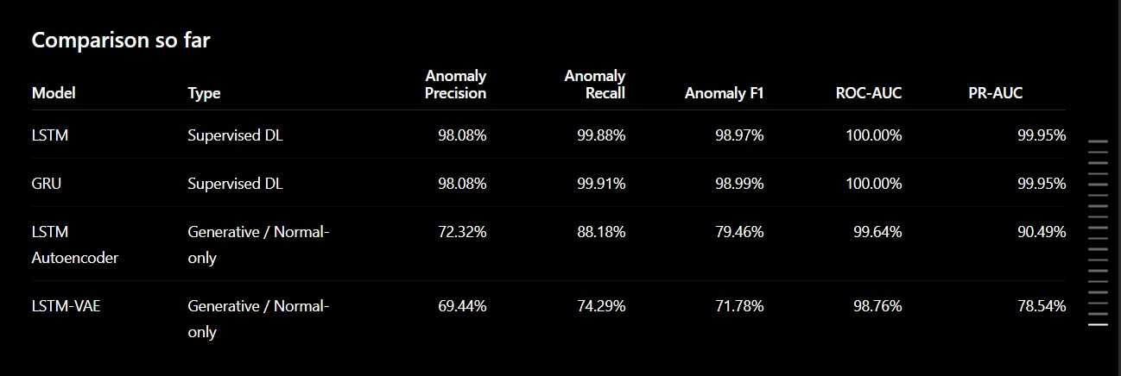B. Spark Logs Analysis
1) Machine Learning Results:
The traditional ML training logs show that Random Forest achieved a near-perfect ROC-AUC of 0.9902, vastly outperforming unsupervised methods like Isolation Forest (0.9559) and One-Class SVM (0.2388). However, despite the high ROC-AUC, the Isolation Forest model struggled with precision (0.04) and F1-score (0.04) for anomaly detection.
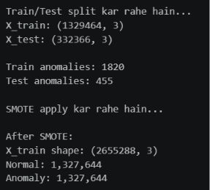

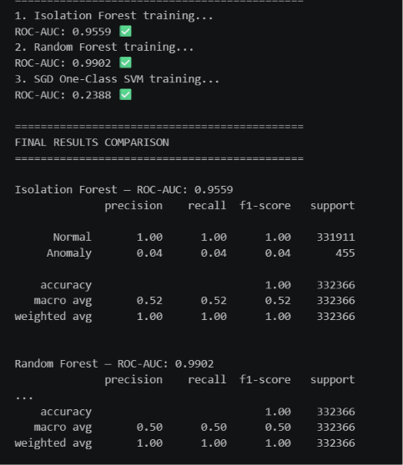

2) Deep Learning Results:
The LSTM Autoencoder model achieved a strong ROC-AUC score of 0.9822 and an excellent recall of 0.93 for anomalies. However, its precision was extremely low at 0.02, leading to an F1-score of just 0.05, indicating a high rate of false positives.
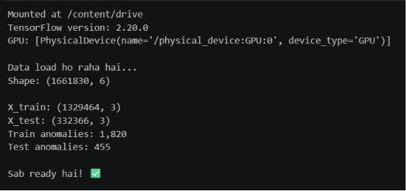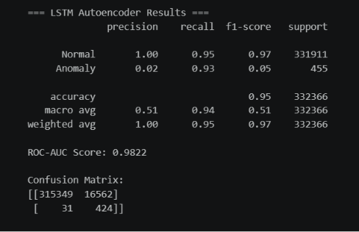
The CNN Classifier recorded the highest overall ROC-AUC for the Spark dataset at 0.9978, with a perfect recall of 1.00. Similar to the LSTM model, it suffered from severe precision issues (0.09), resulting in a low F1-score of 0.16.
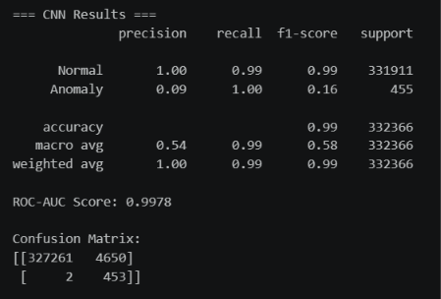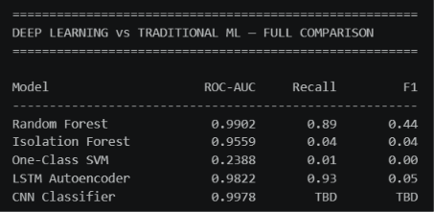
3) Generative AI Results:
Both generative models performed poorly on the Spark dataset. The Variational Autoencoder (VAE) achieved an ROC-AUC of 0.7700 but managed an F1-score of only 0.01, while the Generative Adversarial Network (GAN) failed to detect anomalies effectively, recording an ROC-AUC of 0.2479 and an F1-score of 0.01.
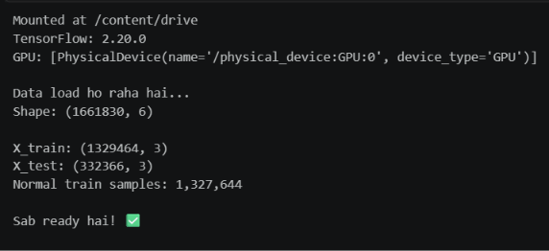
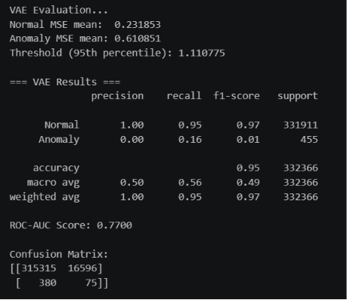
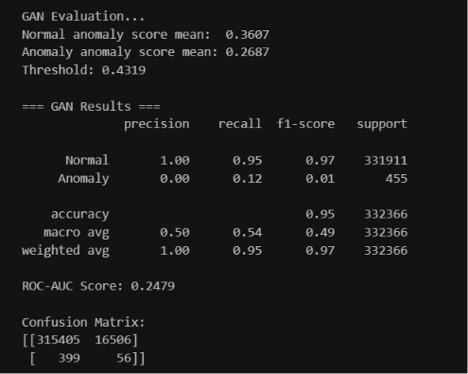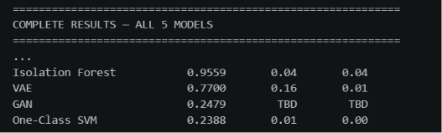
4) Spark Comparative Analysis Synthesis:
The Spark execution logs presented a severe degradation in model efficacy across all architectures.
- Precision Collapse: The complex, overlapping nature of Spark execution logs created a massive false-positive problem. For instance, the LSTM Autoencoder generated 16,562 false positives, dropping its F1-score to just 0.05 despite a strong ROC-AUC of 0.9822.
- Generative Failure: Both generative models performed exceptionally poorly on the Spark dataset. The structural noise and high concurrency of Spark tasks fundamentally disrupted the VAE and GAN's ability to map a stable latent distribution, resulting in F1-scores of 0.01.

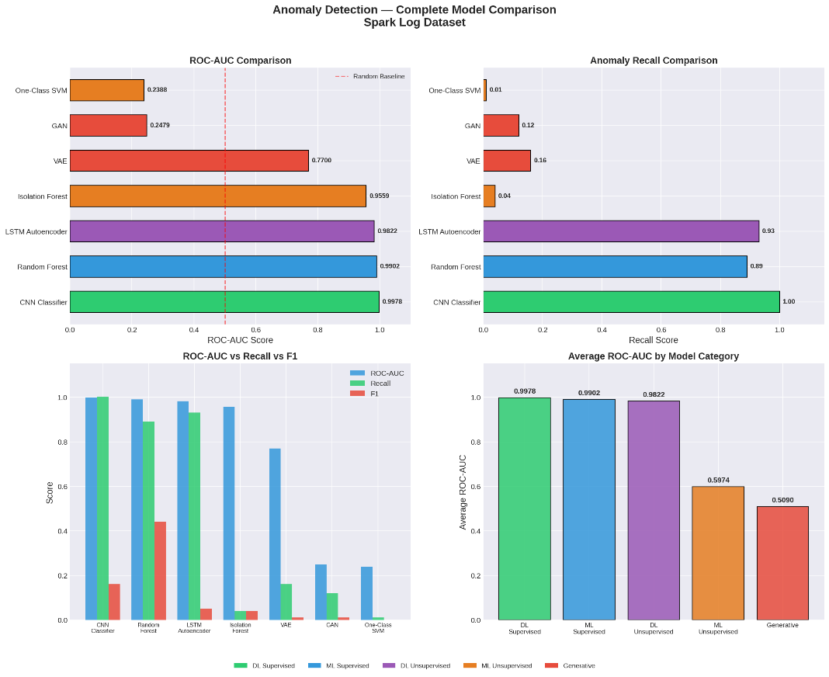
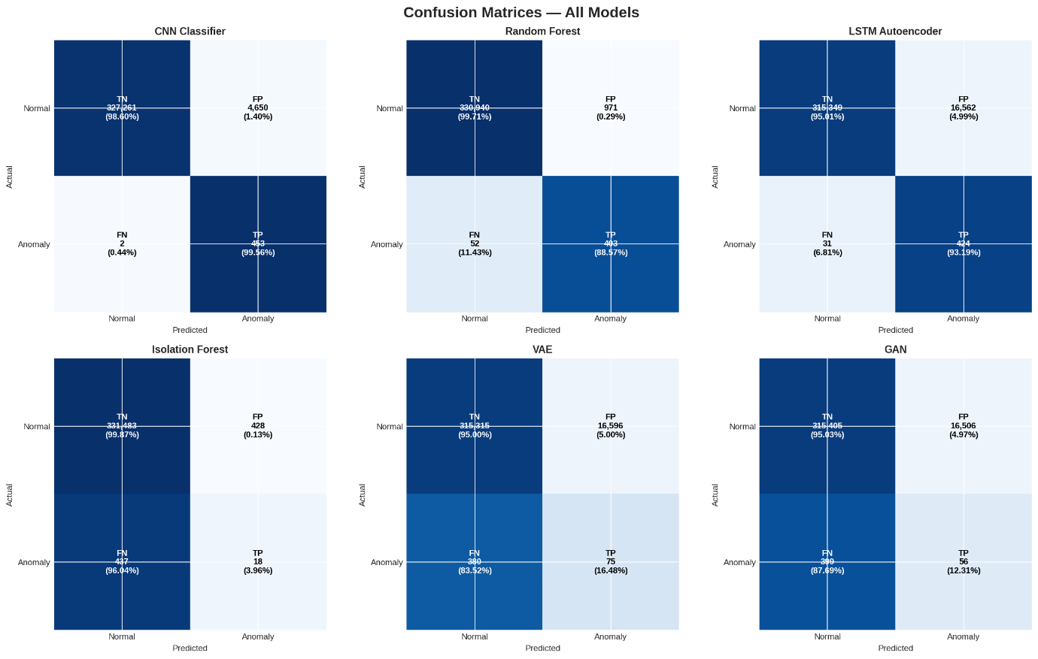
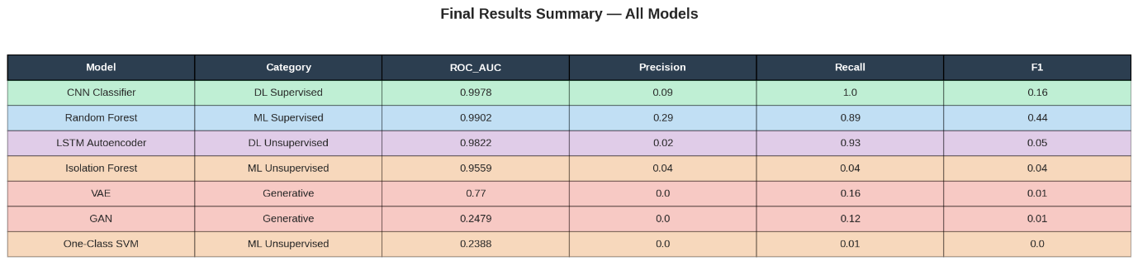

C. Hadoop Logs Analysis
1) Traditional Machine Learning Logs:
In the Hadoop environment, the Random Forest model achieved perfect metrics across the board, logging an ROC-AUC, Recall, and F1-score of 1.0000. Conversely, Isolation Forest and One-Class SVM performed poorly, with ROC-AUC scores of 0.2092 and 0.2383, respectively.
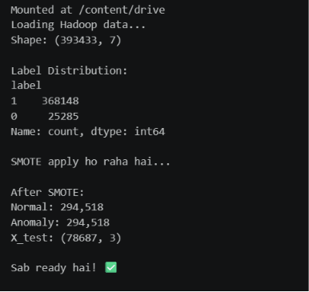
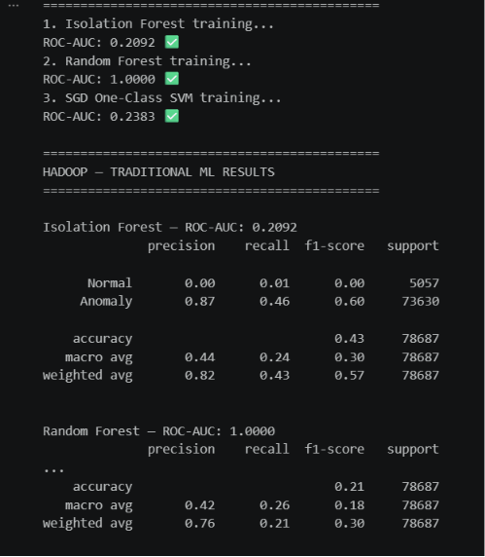
2) Deep Learning (LSTM and CNN):
Deep learning performance was mixed on the Hadoop data. The CNN Classifier performed exceptionally well with an ROC-AUC of 0.9617 and a strong F1-score of 0.91. The LSTM Autoencoder, however, saw a significant drop in performance compared to its Spark results, achieving an ROC-AUC of 0.6519 and an F1-score of 0.45.
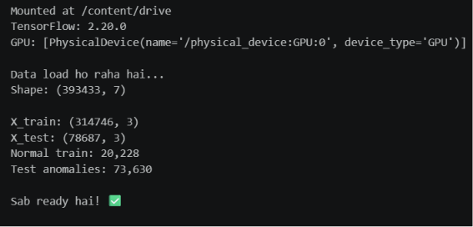
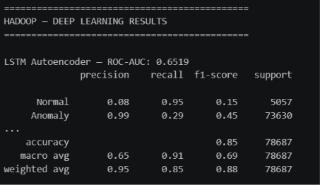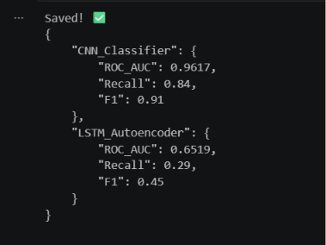

3) Generative AI (VAE and GAN):
Generative models continued to underperform on the Hadoop dataset. The GAN achieved an ROC-AUC of 0.6133 with an F1-score of 0.03, while the VAE recorded an ROC-AUC of 0.5235 and an F1-score of 0.12.
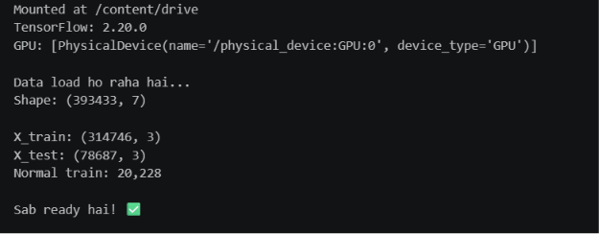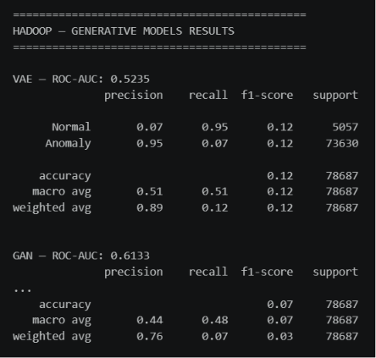

4) Hadoop Comparative Analysis Synthesis:
The summary table and confusion matrices for Hadoop confirm the absolute superiority of the Random Forest model, which recorded 0 false positives and 0 false negatives. The CNN also demonstrated high accuracy with only 50 false positives out of tens of thousands of records.
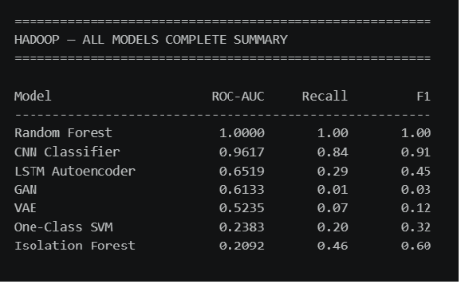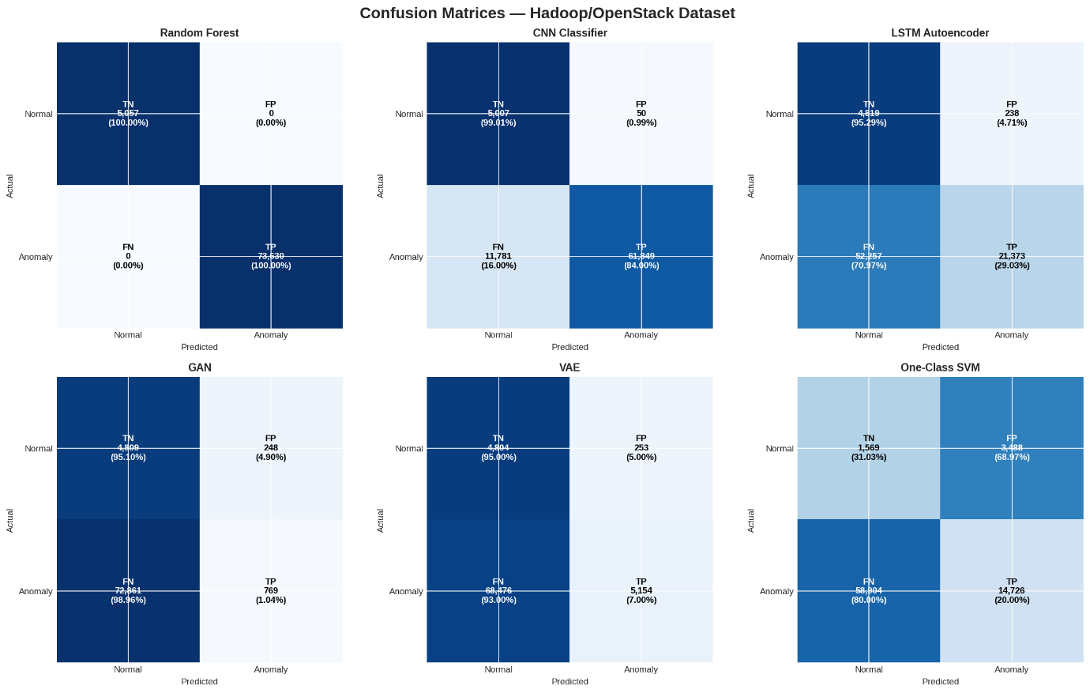

D. Overall Performance Synthesis (Spark vs. Hadoop)
The final heatmap provides a clear visual summary: Random Forest is the most consistently reliable model across both datasets, maintaining high ROC-AUC and the best relative F1-scores. CNN classifiers show excellent ROC-AUC but are highly susceptible to F1-score degradation depending on the dataset (0.16 on Spark vs. 0.91 on Hadoop), while Generative and Traditional Unsupervised models exhibit consistently weak performance across both environments.

Model | Category | HDFS F1 | Spark F1 | Hadoop F1
XGBoost | Traditional ML (Supervised) | 0.9991 | - | -
SVM | Traditional ML (Supervised) | 0.9811 | - | -
Random Forest | Traditional ML (Supervised) | - | 0.44 | 1
LSTM | Deep Learning (Supervised) | 0.9897 | - | -
GRU | Deep Learning (Supervised) | 0.9899 | - | -
CNN Classifier | Deep Learning (Supervised) | - | 0.16 | 0.91
Isolation Forest | Traditional ML (Unsupervised) | - | 0.04 | 0.6
One-Class SVM | Traditional ML (Unsupervised) | - | 0 | 0.32
LSTM Autoencoder | Generative / Unsupervised DL | 0.7946 | 0.05 | 0.45
VAE / LSTM-VAE | Generative | 0.7178 | 0.01 | 0.12
GAN | Generative | - | 0.01 | 0.03
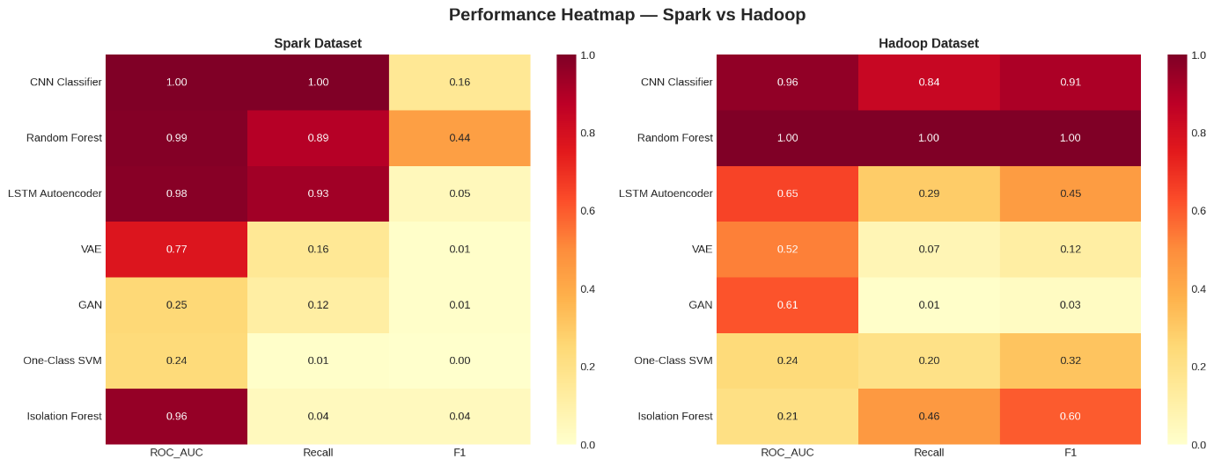
Key Takeaways from the Data:
- The HDFS Illusion: Almost everything performed exceptionally well on HDFS, making it seem like the problem of anomaly detection was solved.
- The Spark Reality Check: Spark completely broke the models. The complex, overlapping nature of Spark execution logs created a massive false-positive problem, dragging almost every model's F1-score below 0.50.
- The Generative Struggle: While Generative AI (LSTM Autoencoder, VAE, GAN) is theoretically great because it doesn't need manual feature engineering, it consistently struggled with noise across all environments, peaking at just 0.7946 on the "easy" HDFS dataset and failing entirely on Spark and Hadoop.
Chapter 5: Conclusion & Future Work
5.1 Conclusion
This thesis presented a comprehensive comparative study evaluating Traditional Machine Learning (ML), Deep Learning (DL), and Generative AI models for automated log anomaly detection across three heterogeneous environments: HDFS, Apache Spark, and Hadoop.
The empirical findings reveal a distinct trade-off between absolute accuracy and functional autonomy. Traditional supervised classifiers (like XGBoost and Random Forest) achieve near-perfect F1-scores on highly balanced or structurally consistent datasets like HDFS and Hadoop, but they remain fundamentally brittle and heavily dependent on labor-intensive, manual feature engineering. Supervised Deep Learning architectures (such as CNNs, LSTMs, and GRUs) successfully eliminate the need for rigid manual feature extraction while maintaining strong performance, yet they demonstrate severe volatility and performance degradation when confronted with the high noise levels and complex concurrency patterns inherent to Spark execution logs.
Conversely, Generative AI models (such as the LSTM Autoencoder, VAE, and GAN) operating under a strictly unsupervised, normal-only paradigm exhibit lower raw precision and F1-scores across the board. However, their consistently high ROC-AUC scores demonstrate that the underlying reconstruction error distributions remain highly separable. Ultimately, while supervised models dominate under closed-world assumptions, generative architectures establish a vital baseline capability for discovering unknown, zero-day anomalies without requiring prior exposure to production failure states.
5.2 Future Work
To address the limitations identified in this comparative framework, future research will focus on the following directions:
- Dynamic Thresholding Mechanisms: Implementing adaptive or extreme value theory (EVT) thresholding to replace static percentile cutoffs, thereby minimizing the high false-positive rates observed in generative models on complex datasets like Spark.
- Concept Drift Mitigation: Investigating online incremental learning and fine-tuning paradigms to ensure deep generative models remain robust as log formats evolve over time alongside software updates.
- Fine-Grained Parameter Classification: Extending the semantic capabilities of raw log embeddings to parse and categorize specific variable fields (such as status codes, IP addresses, and block IDs) rather than relying solely on event sequence IDs.
- Hybrid Neuro-Symbolic Frameworks: Designing unified frameworks that combine the statistical robustness of traditional ensemble methods with the unsupervised flexibility of generative sequence modeling.
References
[1] Zhu, J., He, S., He, P., Liu, J., & Lyu, M. R. (2023). "Loghub: A Large Collection of System Log Datasets for AI-driven Log Analytics." In Proceedings of the 2023 IEEE 34th International Symposium on Software Reliability Engineering (ISSRE), pp. 355-366.
[2] Khan, M. A. M. (2026). "Generative Models vs Traditional AI-Driven Anomaly Detection in Large-Scale System Logs – A Comparative Study." Master's Thesis, Air University, Department of Computer Science (MSAI Program). Referenced from the source working file: "final thesis report asad msai 4 23-6-2026.docx".
[3] He, P., Zhu, J., Zheng, Z., & Lyu, M. R. (2017). "Drain: An online log parsing approach with fixed depth tree." In Proceedings of the 2017 IEEE International Conference on Web Services (ICWS), pp. 33-40.
[4] Du, M., Li, F., Zheng, G., & Srikumar, V. (2017). "DeepLog: Anomaly detection and diagnosis from system logs through deep learning." In Proceedings of the 2017 ACM SIGSAC Conference on Computer and Communications Security, pp. 1285-1298.
[5] Zhang, X., Xu, Y., Qin, S., He, S., Biao, Q., Li, Z., ... & Zhang, D. (2021). "Onion: Identifying incident-indicating logs for cloud systems." In Proceedings of the 29th ACM Joint Meeting on European Software Engineering Conference and Symposium on the Foundations of Software Engineering (ESEC/FSE), pp. 1253-1263.
[6] Xu, W., Huang, L., Fox, A., Patterson, D. A., & Jordan, M. I. (2009). "Detecting large-scale system problems by mining console logs." In Proceedings of the ACM SIGOPS 22nd Symposium on Operating Systems Principles (SOSP), pp. 117-132.
[7] Liu, F. T., Ting, K. M., & Zhou, Z. H. (2008). "Isolation forest." In Proceedings of the 8th IEEE International Conference on Data Mining (ICDM), pp. 413-422.
[8] Lin, Q., Zhang, H., Lou, J. G., Zhang, Y., & Chen, X. (2016). "Log clustering based problem identification for online service systems." In Proceedings of the 38th International Conference on Software Engineering Companion (ICSE-C), pp. 102-111.

